Thermistor Curve Fitting

Gaylon Campbell

The Steinhart-Hart equation is often used to determine temperature of negative temperature coefficient thermistors from thermistor resistance. If Θ is temperature in kelvins, and R is resistance

$\frac{1}{Θ}=A+B ln\left(R\right)+C{\ln\left(R\right)}^{2}+D{\ln\left(R\right)}^{3}$ (1)

A, B, C, and D are coefficients determined from least-squares fits of resistance to temperature data. In the actual Steinhart-Hart equation the quadratic term is left out, but it is hard to see why one would do that. Presumably an additional term will improve the fit, and it isn’t much of a burden on a processor. Here is a graph of ln(R) vs. reciprocal kelvin temperature for the temperature range we often use of -50 C to 50 C. Note that transforming temperature and resistance that way makes it almost a straight line.

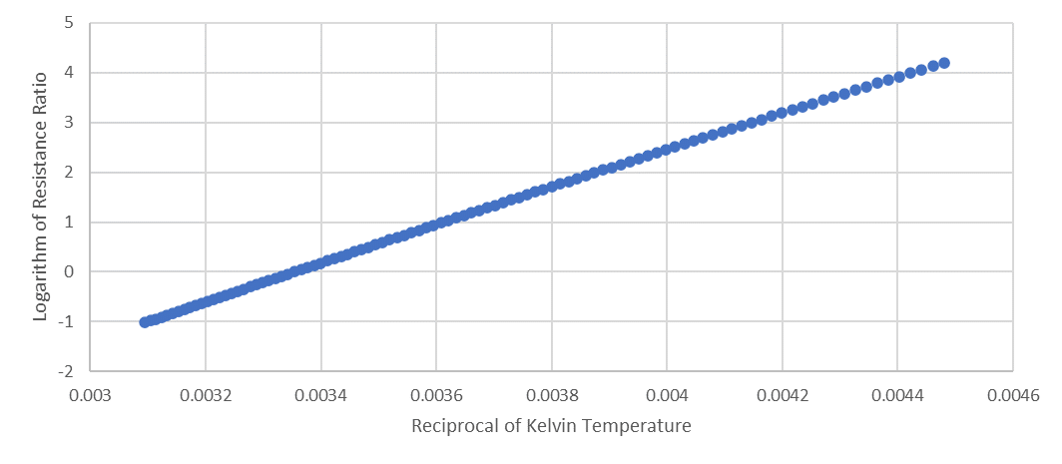

For some reason, I always thought the Steinhart-Hart equation was

$T=A+B ln\left(R\right)+C{\ln\left(R\right)}^{2}+D{\ln\left(R\right)}^{3}$ (2)

where T is the Celsius temperature. The constants, again, are fit by least squares to the data, and obviously are not the same as those in eq. 1. The following graph shows the relationship between ln(R) and T over the same temperature range. This line is pretty straight but has a bit more curvature.
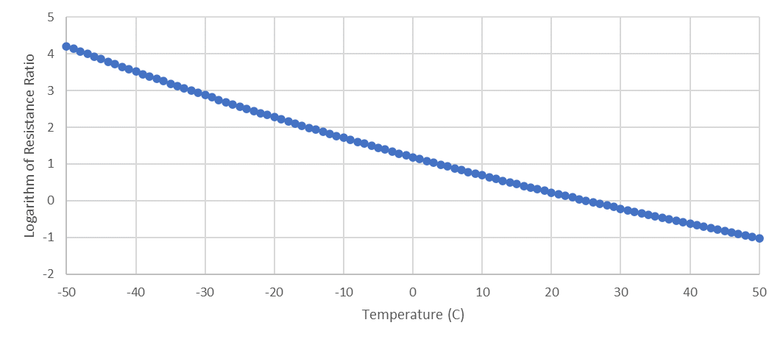
Most, if not all, of the thermistor curve fitting at Decagon/Meter has used eq. 2, so, which one is best? In a recent project we were extending the Atmos 41 temperature range to -65C. To do that, we needed to extrapolate the calibration from -50C to -65C, since we have no calibration data below -50C. I fit ln(R) to reciprocal kelvin temperature, and to Celsius temperature down to -50C, then extrapolated those curves to -65C, then fit eqs. 1 and 2 to the two data sets. From those and the resistances, I calculated the temperatures and compared them to the original temperatures. The following graph compares the two equations. Blue is from eq. 1 and orange is from eq 2.
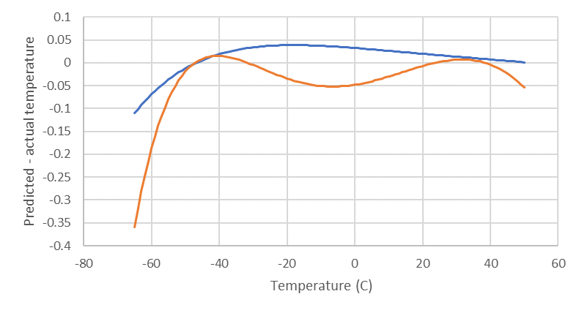
My conclusion is that the equations we have used for a long time are fine for the range we normally use them in, but the real Steinhart-Hart equation does better, especially below -50C. So I don’t think we need to go back and change anything, but I probably need to stop calling our old equation Stinehart-Hart. For future curve fitting we probably should use eq. 1. NorthStar Sensors has some good resources on their website here https://www.northstarsensors.com/calculating-temperature-from-resistance. They provide Excel spreadsheets with the thermistor resistance ratios for each degree from -50C to 150C, which make it easy to do the calculations. All of the bead thermistors we use (in water activity meters, Atmos 22 and 41, Teros 12, and Tempos) were the old Conerstone D curve. NorthStar Curve 44 is that same calibration.

